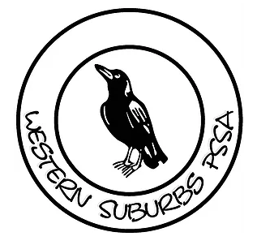

WSPSSA
ZONE CROSS COUNTRY

Wednesday 26th May 2021
Timbrell Park, Five Dock

WSPSSA Spectator
Sign In/Out
QR Code

Please follow the instructions
outlined on the form

2KM CROSS COUNTRY MAP

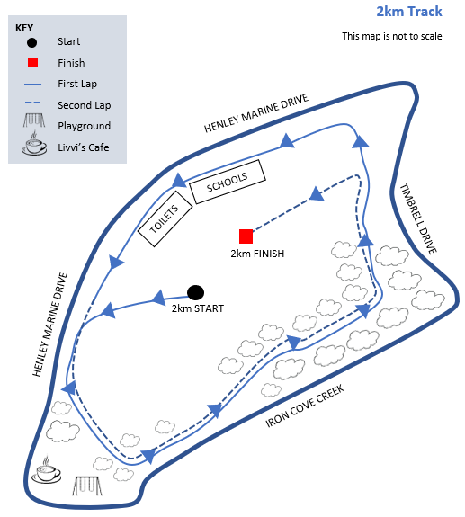

3KM CROSS COUNTRY MAP

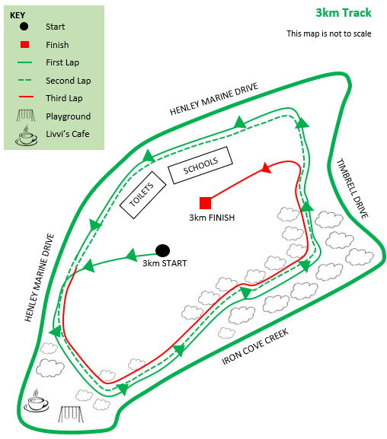

PROGRAM OF EVENTS
(Commencing at 11:00am)

11:00am – Walk the course
11:45am – First race to start
Race 1 – 8/9 years Girls (2km)
Race 2 – 8/9 years Boys (2km)
Race 3 – 10 years Girls (2km)
Race 4 – 10 years Boys (2km)
Race 5 – 11 years Girls (3km)
Race 6 – 11 years Boys (3km)
Race 7 – 12/13 years Girls (3km)
Race 8 – 12/13 years Boys (3km)
Approximately 2pm – Cross Country Carnival Finishes

Please note:
- There are no set times for each race.
- Children will walk the course at approximately 11:00am
- First race will commence at 11:45am
- Races will be run after each previous race has finished.

IMPORTANT INFORMATION

- Suitable footwear must be worn – NO SPIKES.
- Competitors must be members of the Zone Team.
- The first 6 place getters in each event will represent the Western Suburbs Zone at the Sydney East PSSA Cross Country Carnival on Friday 11th June 2021 at Miranda Park, Miranda.
- The first 8 place getters in each event will receive ribbons and a permission note. These notes need to be returned to their school’s cross country coordinator on the 27th May.
- 7th and 8th place getters will be reserve runners. They will not attend the regional carnival unless notified by the convener.

